COMMUNICATION CIRCUIT DESIGN – LAB 1

**Problem Statement 1:**

Design Butterworth analog low pass filter having following specifications: -  
rp=0.15, rs=60, wp=1500, ws=3000, fs=7000

Plot frequency and phase response.

**Code:-**

% Lowpass filter

rp=0.15;

rs=60;

p=1500;

s=3000;

fs=7000;

wp=(p*2)./fs;

ws=(s*2)./fs;

[nl,wl]=buttord(wp,ws,rp,rs,'s');

[zl,pl,kl]=butter(nl,wl);

[b,a]=butter(nl,wl,'s');

w=0:0.01:2*pi;

[h,wo]=freqs(b,a,w);

m=20*log10(abs(h));

an=angle(h);

subplot(2,1,1);

plot(wo/pi,m);

xlabel("Normalised Frequency");

ylabel("Gain in dB");

subplot(2,1,2);

plot(wo/pi,an);

xlabel("Normalised Frequency");

ylabel("Phase in Radians");

sgtitle(sprintf('n= %d Order Lowpass Butterworth Filter',nl));

figure;

**Output for Q1.):**

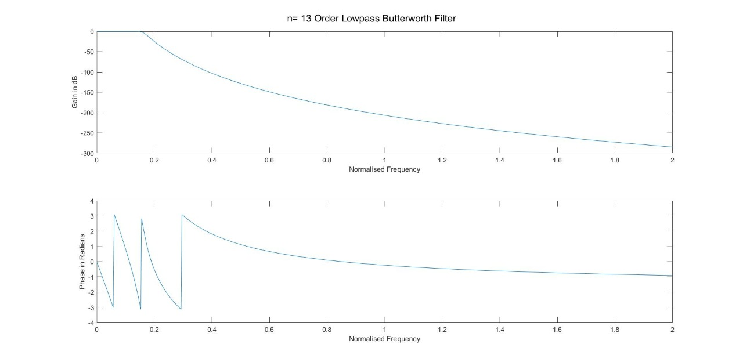

**Problem Statement 2:**

Design Butterworth analog high pass filter having following specifications: -

rp=0.20, rs=40, wp=2000, ws=3500, fs=6000

Plot frequency and phase response.

**Code:-**

% Highpass filter

rp=0.2;

rs=40;

p=2000;

s=3500;

fs=6000;

wp=(p*2)./fs;

ws=(s*2)./fs;

[nh,wh]=buttord(wp,ws,rp,rs,'s');

[zh,ph,kh]=butter(nh,wh,'high','s');

[b,a]=butter(nl,wl,'high','s');

w=0:0.01:2*pi;

[h,wo]=freqs(b,a,w);

m=20*log10(abs(h));

an=angle(h);

subplot(2,1,1);

plot(wo/pi,m);

xlabel("Normalised Frequency");

ylabel("Gain in dB");

subplot(2,1,2);

plot(wo/pi,an);

xlabel("Normalised Frequency");

ylabel("Phase in Radians");

sgtitle(sprintf('n= %d Order Highpass Butterworth Filter',nh));

**Output For Q2.)**

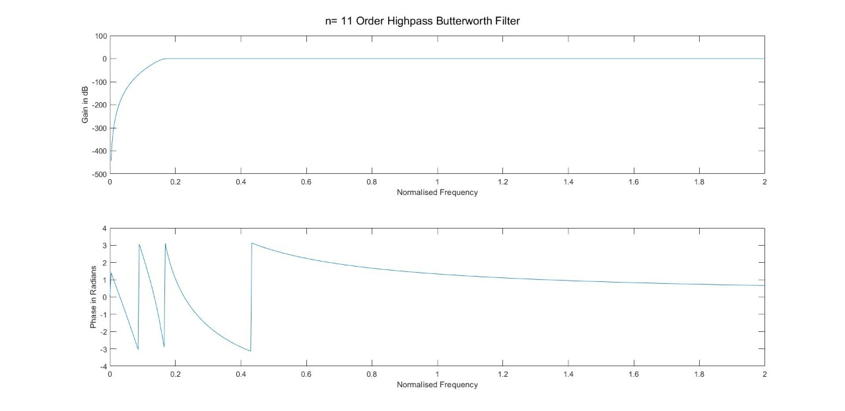

**Conclusion:-**

I wrote a code in Matlab to implement and visualize Butterworth Lowpass and High-pass filters for given values of its specifications. At the same time, I observed the frequency and phase response of the same.